**Assignment 1: Installation**

**Name: Padmapriya Palanisamy**

**Power BI Desktop Installation:**

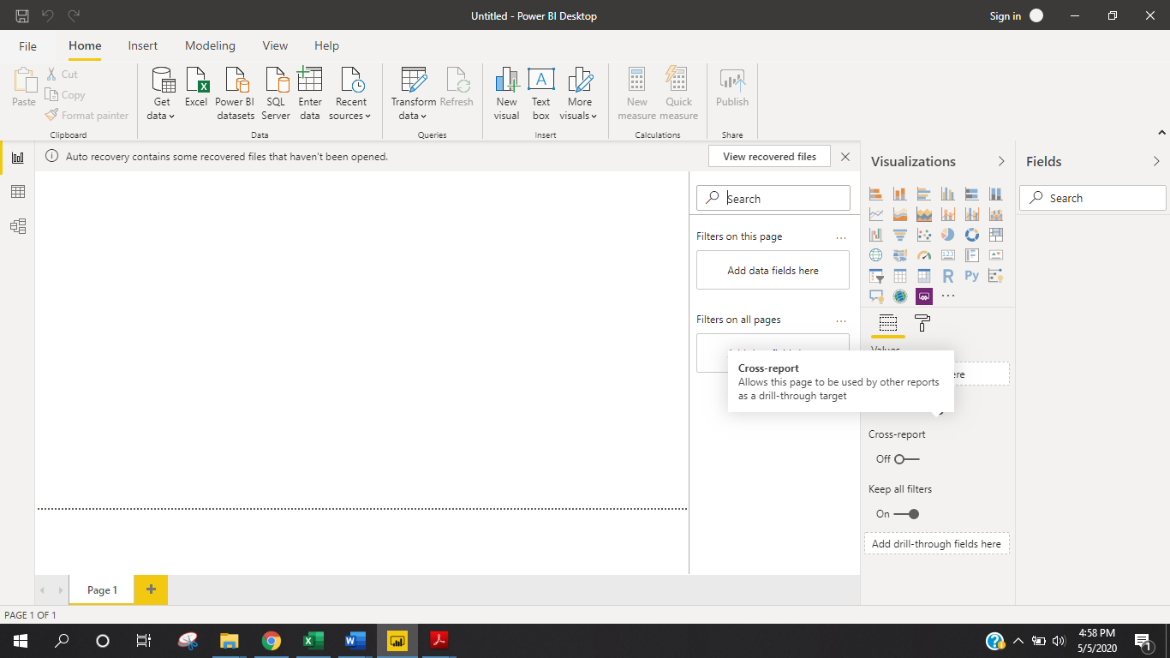

* **Report View**

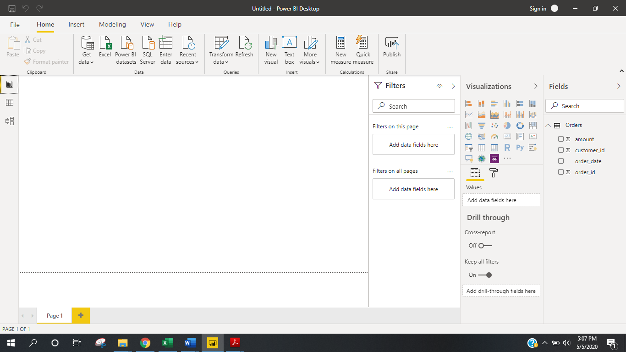

* **Data View**

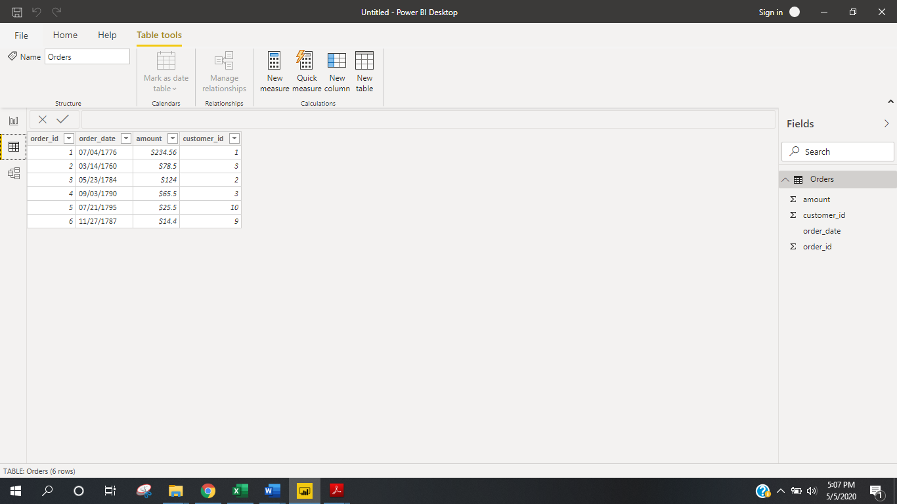

* **Model view:**

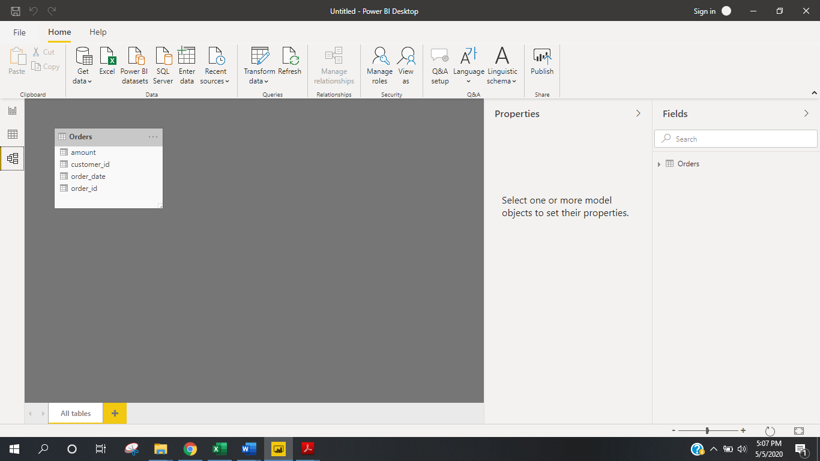

* **Power Query Editor**

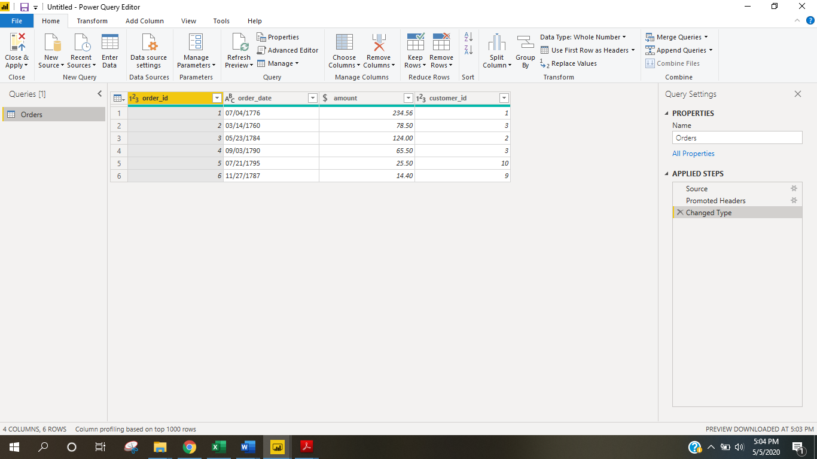

**Power BI Desktop:**  It is free application we can install it in our local computer and helps to connect with different sources and also combine them into data model. We can build the visuals and share the visuals as reports and charts with other people.

It is **free application** we can install it without any cost in our local computer.

**Power BI Pro:** It is an individual user license and allows user to read and interact with other reports and dashboards published in Power BI services. The user can share content with other users.

It costs**$9.99/user/month**. Also, user can have free trial for 60 days before purchasing the subscription.

**Power BI Premium:** It is Enterprise level Power BI and has capacity-based offering that includes: Flexibility to publish reports broadly across an enterprise, without requiring recipients to be licensed individually per user. Greater scale and performance than shared capacity in the Power BI service

The Premium plan starts at **$4,995 a month** per dedicated cloud compute and storage resource